

American International University- Bangladesh

CSC 3222: Web Technologies

CO1.1 and CO2.1 Evaluation

Project Report

Spring 2021-22

Project Title: Agriculture E-commerce

Section: F

|  |  |
| --- | --- |
| Student Name | Student Id |
| Samir Faisal | 19-41037-2 |
| Nasim Reza Hridoy | 19-41045-2 |
| K.M.WASIMUL BARI | 19-40288-1 |
| MD. HASNAT HOSSAIN HEMAL | 19-40614-1 |

Introduction:

This project is based on agriculture e-commerce where farmer can sell goods directly to the consumer. Nowadays, people of urban city are paying more money to buy goods. This is serious issue in current situation. For this reason, people of low- and lower-middle-income groups are spending all of their income to buy only essential things. That is why, we doing this project.

Background Study

We live in an agricultural country. Agriculture is the most important sector of Bangladesh economy. To help this sector improve and we develop agriculture-based e-commerce website which name is “Chasi Bazar”. This website will have 4 sorts of users which are admin, seller, buyer and delivery man. Each user has appropriate access to functionalities of the website. We will use HTML, CSS and PHP to develop this website. We searched several websites for gathering more knowledge about agriculture e-commerce and find efficient delivery system and how to visualize product to attract buyer. And also, we find an issue like backdated payment method. For this reason, we add hustle free and advanced payment method which is completely buyer and seller friendly.

Reference Site:

<https://www.agribazaar.com>

https://farmersmarketcoalition.org

<https://marketbangla.com>

Requirement Analysis:

1. User Category:

There are 4-types of Users here. They are:

* Admin
* Seller
* Buyer
* Deliveryman

1. Feature List:

In this project the “Admin” has the following features:

* Login
* Create Account
* Profile
* Logout
* ADD or delete all of user
* Chat
* Add or Delete product
* Control Payment System

In this project the “Seller” has the following features:

* Login
* Create Account
* Profile
* Logout
* Chat
* Tracking Order
* Add or Delete product
* Report or Block

In this project the “Buyer” has the following features:

* Login
* Create Account
* Profile
* Logout
* Buy Product
* Add to Cart
* Make Payment
* Chat
* Tracking Order
* Feedback or Review
* Report or Block
* Add or Delete product

In this project the “Deliveryman” has the following features:

* Login
* Create Account
* Profile
* Logout
* Show Status
* Accept or Decline Order
* Complain
* Fare
* Chat

Design:

Buyer

Admin

Seller

Modify

Modify

Deliveryman

Deliver

Goods

Modify

Modify

Tools Used: UMLet

To develop this project, we have used the following:

• Chrome Browser

• Xampp

• Visual Studio Code

• Adobe XD

• UMLet

• My sql

System Images against the Specification:

Home page: This is the home page of this site where any type of user can access their profile through login. User(Seller, Buyer, Deliveryman) can see offers, and connect with admin through email and phone number.

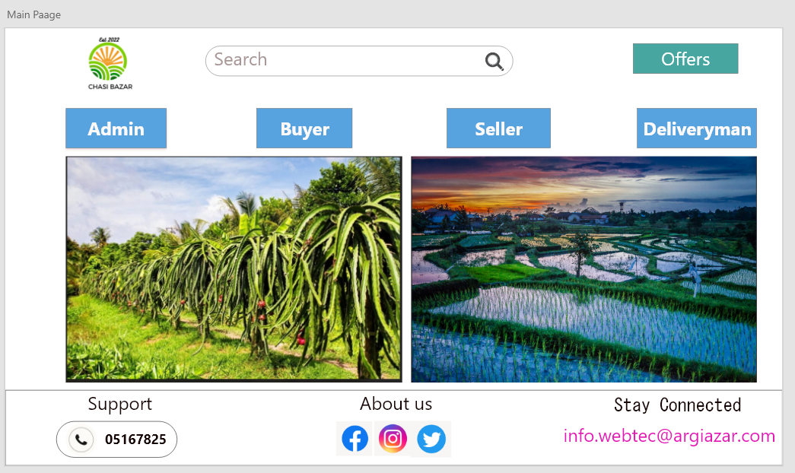

Login Page: User can go profile page thorough correct username and password or go to Registration option if he/she new to this site.

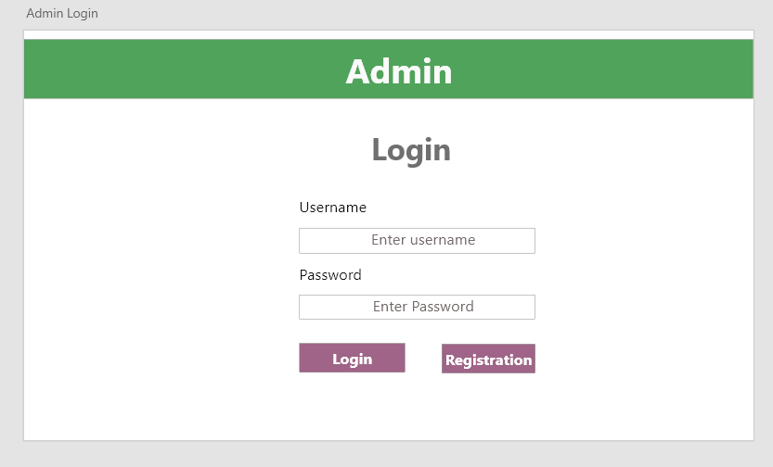

Create Account page: User can create new account if he/she does not any have account. 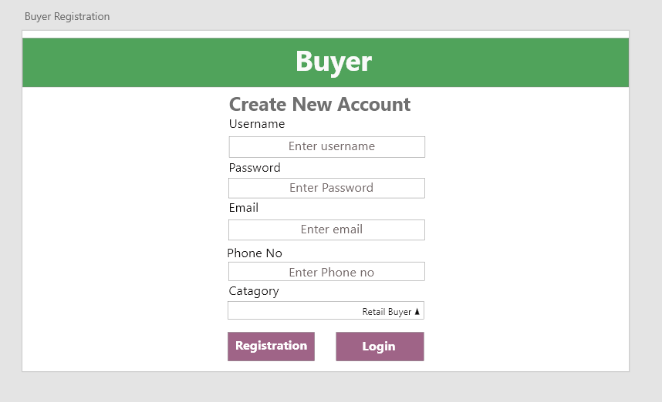

Profile Page: User can change online status and see history. And also change email and phone number. Other users have same type of function with extra features.

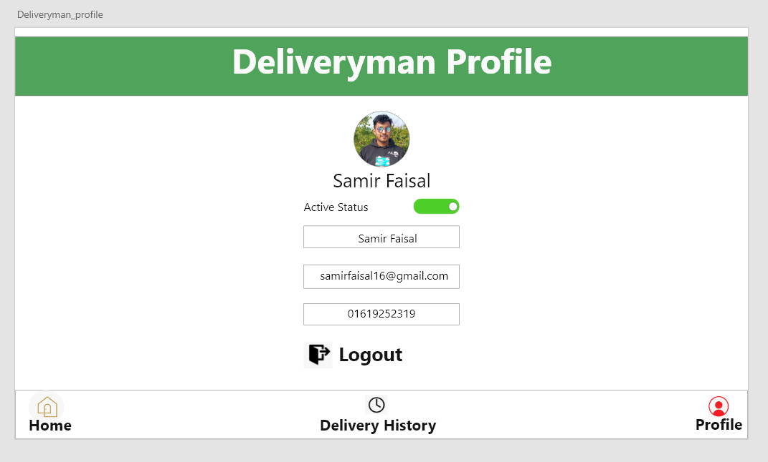

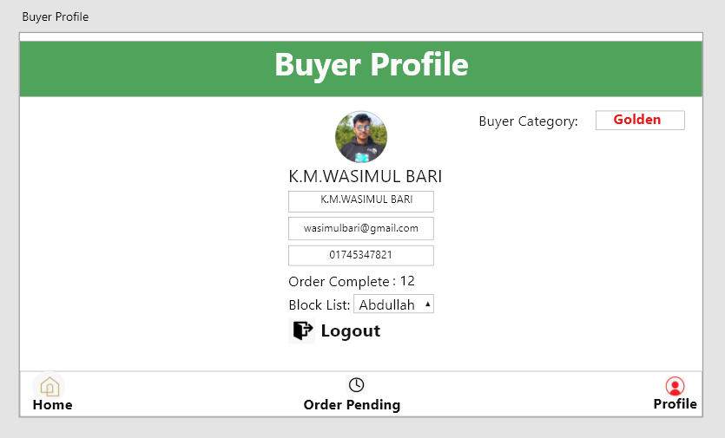

Impact of this Project:

Due to poor market infrastructure, farmers in Bangladesh are suffering from getting sufficient selling price from their crops from the middlemen. Due to this issue many farmers are getting demotivated from farming. Also on the consumer side, people are also suffering from immoderate prices when buying products. So we want to look into this matter and come up with a plan in order to solve this issue, where farmers will get their adequate amount of pay on their selling of crops and customers will be able to purchase those products at a reasonable price. This will motivate farmers to continue their farming and it will be easier for common folks to afford those products.

Limitations and Possible Future Improvements:

**Limitation:

1)We did not add any Product verifying function.

2)There will be some bugs or mistakes in our project.

3)We don't have Cloud Data Center.

**Future Plan:

1)We will add Advanced Security Feature So that no malware cannot break the system.

2)We will work on update which we got from our feedbacks.

3)We will make this project on Mobile application.

4)We have better plan for this project so that it can be more user friendly.

5)We are going to make IOS and HarmonyOS Application.

*[Note: Make sure that your report is maximum 10 pages (including cover page). Print (Colored) the report and submit it with spiral bind.]*

|  |  |  |  |  |  |
| --- | --- | --- | --- | --- | --- |
| CO1.1 and CO2.1 Evaluation: Project Report Evaluation | | | | | |
| Project Proposal  (5) | Background  Study  (5) | Requirement Analysis  (5) | Entity  Diagram  (5) | System Images  against the  Specification (5) | Total (25) |
|  |  |  |  |  |  |
|  | | | | | |